**UNIVERSITI TUN HUSSEIN ONN MALAYSIA**

**STATUS CONFIRMATION FOR UNDERGRADUATE PROJECT REPORT**

**MES Factory Software Implementation and KI factory explanation**

**ACADEMIC SESSION: 2023**

I, Moritz Hoehnel agree to allow this Undergraduate Project Report to be kept at the Library under the following terms:

1. This Undergraduate Project Report is the property of the Universiti Tun Hussein Onn Malaysia.

2. The library has the right to make copies for educational purposes only.

3. The library is allowed to make copies of this report for educational exchange between higher educational institutions.

4. ** Please Mark (√)

√

|  |  |
| --- | --- |
| CONFIDENTIAL | (Contains information of high security or of great importance to Malaysia as STIPULATED under the OFFICIAL SECRET ACT 1972) |
| RESTRICTED | (Contains restricted information as determined by the Organization/institution where research was conducted) |
| FREE ACCESS |  |

Approved by

(WRITER’S SIGNATURE) (SUPERVISOR’S SIGNATURE)

Permanent Address:

NO19A, Jalan Kencana,

83300 Pura Kencana

BATU PAHAT,

JOHOR

Date: ______________________ Date: ______________________

NOTE:

** If this Undergraduate Project Report is classified as CONFIDENTIAL or RESTRICTED, please attach the letter from the relevant authority/organization stating reasons and duration for such classifications.

**MES Factory Software Implementation and KI factory explanation**

Moritz Hoehnel

A thesis submitted in partial

fulfilment of the requirement for the award of the

Bachelor’s Degree of Mechanical Engineering with Honours

Faculty of Mechanical and Manufacturing Engineering

Universiti Tun Hussein Onn Malaysia

August 2023

I hereby declare that the work in this project report is my own except for quotations and summaries which have been duly acknowledged

Student : ……………………………………………………

Moritz Hoehnel

Date : ……………………………………………………

Supervisor : ……………………………………………………

Prof. Madya Ir. Dr. Low Cheng Yee

Co Supervisor : ……………………………………………………

Prof. Madya Ts. Dr. Zakiah Binti Kamdi

ACKNOWLEDGEMENT

We would like to use this space to give a special acknowledgment for Dr. Low Cheng Yee, who always supported us in every matter.

We would like to also thank all the persons working in the UTHM-Frauenhofer IEM Innovation Lab. It was great working together with very helping people. It was a great experience being part of the project learning factory.

ABSTRACT

This is where you should start your writing of your abstract. Don’t change any of the setting.

ABSTRAK

Di sini anda sepatutnya memulakan penulisan abstrak. Jangan ubah *setting* yang telah dibuat. Jika penulisan abstrak ada melibatkan penggunaan ayat bahasa Inggeris, ayat tersebut mesti di *Italic*. Rujuk format penulisan tesis.

CONTENTS

TITLE i

DECLARATION ii

ACKNOWLEDGEMENT iii

ABSTRACT iv

ABSTRAK v

LIST OF TABLES a

LIST OF FIGURES b

LIST OF SYMBOLS AND ABBREVIATIONS c

LIST OF APPENDICES d

CHAPTER 1 INTRODUCTION 2

1.1 Background Study (use Heading 2 style) 2

1.2 Problem Statement (use Heading 2 style) 2

1.3 Aim 2

1.4 Objectives 2

1.5 Scope of Study 2

1.6 Significant of study 2

CHAPTER 2 LITERATURE REVIEW 2

2.1 Using Captioning and Cross Referencing 2

2.1.1 Captioning 2

2.1.2 Cross Referencing 2

2.1.3 Updating Tables of Contents, Lists of Figures and Captions 2

CHAPTER 3 METHODOLOGY 2

3.1 Title (use Heading 2 style) 2

3.1.1 Title (use Heading 3 style) 2

CHAPTER 4 RESULTS AND DISCUSSION 2

4.1 Title (use Heading 2 style) 2

4.1.1 Title (use Heading 3 style) 2

CHAPTER 5 CONCLUSION AND RECOMMENDATIONS 2

5.1 Title (use Heading 2 style) 2

5.1.1 Title (use Heading 3 style) 2

REFERENCE a

APPENDIX b

LIST OF TABLES

2.1 Put a table title (use ‘Caption’ style) 2

LIST OF FIGURES

2.1 Gas Turbine (use ‘Caption’ style) 2

LIST OF SYMBOLS AND ABBREVIATIONS

|  |  |  |
| --- | --- | --- |
| MES | - | Manufacturing Execution System |
| PLC | - | Programmable Logic Controller |
| AI | - | Artificial Intelligence |
| PC | - | Personal Computer |
| VDI | - | Verein Deutsche Ingenieure, *engl*. Association of German Engineers |
| ERP | - | Enterprise Resource Planning |
| ISA | - | International Society of Automation |
| CNN | - | Convolutional Neuronal Network |
| RNN | - | Recurrent Neuronal Network |
| OPCUA | - | Open Platform Communications United Architecture |
| URL | - | Uniform Resource Locator |
| SQL | - | Structured Query Language |
| JSON | - | JavaScript Object Notation |
| NFC | - | Near Field Communication |
| IoT | - | Internet of Things |
| MQTT | - | Message Queuing Telemetry Transport |
|  |  |  |

LIST OF APPENDICES

|  |  |  |  |
| --- | --- | --- | --- |
| **APPENDIX** | **TITLE** |  | **PAGE** |
| A | (Put your title here) |  | xx |

# INTRODUCTION

## Background Study

“The fourth industrial revolution is accelerating more and more. The foundations for a completely connected ‘smart factory’ are set. Digitalization, robotics, artificial intelligence […]. Today, these developments are changing industrial production fundamentally. […] Physical and digital processes are becoming increasingly intertwined. This also includes networking with customers: Their needs and demands are and remain the guiding principle of all of the company's work.” (Mercedes-Benz Group: <https://group.mercedes-benz.com/innovation/case/connectivity/industry-4-0.html>, 20.05.2023). The Mercedes-Benz Group, one of the world’s leading car manufacturers, stating that the current industrialization is having an increasing effect. As three main pillars they name the digitalization, advancing robot technology and artificial intelligence. All these pillars get more and more integrated into production processes, as they have positive effect on production costs.

One goal of Industry 4.0 is to connect workers and machines. Digitalization is providing a platform to collect production data from machines as well as humans. They can be analysed and translated into languages machines and humans understand. Advancing robot technologies are helping to support and take over production steps. Especially those that human can not handle, as example working in a hot environment. The third pillar, Artificial intelligence, is advancing analysing the processing of production data.

The goal of this project is to work on a factory simulation that is capable of all the previous requirements for a future factory. The factory is completely operated by robots, to establish one pillar. For the first part of this project a Manufacturing Execution System (MES) should be established. It is used to collect the sensor data, safe it to a cloud and then send it to inform the workers and machines that are part of the production. This means that it takes the pillar of Digitalization. The second step of the project shall establish the third pillar, the artificial intelligence. It should be used to analyse the production data.

Apart from optimizing the production itself, the Mercedes-Benz Group outlines that the need for providing information to the customers also becomes more important. The MES has matching options for this purpose and shall be used to provide production information.

## Problem Statement and Real World Application

While economy leading companies have already implemented important steps that are considered to be part of the fourth industrial industrialization, local companies often lack those realization steps. Many companies are not using robots neither are they digitalized. The factory simulation is established to show them the advantages as well as giving them input for implementation.

Looking at the advantages, the aim should be to improve their factoring process. The primary goal of the fourth industrial revolution for local companies should be to reduce failures during production and with that saving money. But with knowing how to establish a more digitalized production system, companies can also use the other benefits that are coming along. As examples one can take a possible reduction of workers or the information chain for customers.

To improve the understanding of the simulated production process, a real-world factory is taken as example. The example is about a rim manufacturer for cars. In their factory they have a warehouse, an oven, a milling machine and after production workpieces get stored depending on colour. The rims can be ordered in colours red, blue and white. In the beginning an order picker collects raw material, puts it into an oven to temper the material. After the hardening is finished, the workpiece needs to be carried to the milling machine. After that, a person need sort it by colour into the right chute for the final storage.

The factory simulation shows how to automate all these work steps. For implementation at first robots are introduced. All the work steps that were executed by a human can also be handled by a robot. That means that one robot can fetch the raw material, a further robot can deliver the workpieces to the factoring sites. Convey belts can transport the workpieces between the factoring steps and finally to the chutes. With using a colour detecting sensor, sorting workpieces can be executed automatically. After implementing the robots just one worker to overview all production steps is necessary. As a reduction in total number of laborers is possible, a result is lower production costs.

To make it easier for the worker overviewing the production site production will be digitalised. This includes that data is gathered, analysed and visualized. In a final step, the pillar of artificial intelligence is deployed. An intelligent software is then in charge of controlling the production. It can also work with the provided production site data. If all is working perfectly together, there is just a production site manager of the rim producing company necessary to overview the progress of the factory, as execution, monitoring and controlling is done by software tools.

## Objectives

This chapter provides the specification of the project. It will be defined what is needed to be done to complete the projects. It will be described what the MES and Lernfabrik objectives are.

For the MES the final goal is to build a dashboard that gives an overview over the current production steps. Steps of data collection form the factory need to be made in order to achieve that.

For the second part of the project the task is to explain how to make the AI-Campus Lernfabrik software work with the learning factory in the laboratory. A course explanation in English needs to be delivered.

### General Description of the product

The following parts will explain more detail what the finished products should look like. Therefore, a summary of the functions, a perspectives analyzation and a user characteristics analyzation will be made. These chapters are necessary to determine how the results look like. They are also a guideline during development.

#### Product functions

For the first part of the project a MES software is used. It is used to digitalize manufacturing processes. The process data should be put together in a dashboard. This dashboard should be usable for different persons. The first group of persons are the factory workers. The second group of persons are those that oversee the production. Both need to know which production step is running and which products are completed.

For the AI-Campus learning factory a set of explanations will be created. This will include a user manual and a workshop in which the functions will be discussed. Furthermore, it will be evaluated what steps need to be done to have the learning factory ready to implement to the software of the Lernfabrik.

#### Product perspective

The factory is shown on an exhibition table. The results of the implementation of the MES Software can be accessed via a PC and a screen. The dashboard can be accessed with any PC that is connected to the UTHM network. It is also required to have Arcstone credentials to open the dashboard. For show purposes it is advised to locate the screen right next to the factory, so the prospects are able to compare what they can see happening at the factory and how the dashboard is visualizing it.

The AI-Campus factory learning material will be given digitally. It includes workshop materials. These should consist of two documents. A deeper explanation of every step and software that is used and a step by step instruction to solve example tasks.

#### User characteristics

The expected users of the MES software divide into two groups: Workers and Managers.

The workers has expertise for all the steps of the factory. He also expertise will be to use the PLC software in a way that he knows how to start the execution of the factory. He probably has no higher education and won’t be able to implement any changes to the PLC software. It will also be hard for him to read complex graphs. This means that data shown on the dashboard must be simple.

The manager will have higher education. He has experiences with complex software. He needs to overview that the MES software is running correctly.

## Scope of Study

The following chapter is describing the exact tasks that need to be performed. The tasks are collected in tables and are split for each subject. The following list shows abbreviations used specifically for the tables of this chapter:

|  |  |  |
| --- | --- | --- |
| ID | - | Is the identification number of a specification. |
| Pr. | - | Is the priority of a specification. It specifies whether a goal has to be achieved or not.  A: Has to be fulfilled (Verification needed).  B: Should be fulfilled  C: Can be fulfilled |

### Functional Requirements

#### MES software

|  |  |  |  |  |
| --- | --- | --- | --- | --- |
| ID | Name | Description | Verification | Pr. |
| A.01 | Data collection | With arc.quire data of the factory must be demanded | Software verifies connection | A |
| A.02 | Database | A database table needs to be created, that is capable to store all important data. | Load data into database | A |
| A.03 | Database | Data from the factory must be stored into the database. | Request list of database. | A |
| A.04 | Dashboard Pre-processing | Data has to be filtered, sorted and allocated to a meaning | Understandable data | A |
| A.05 | Dashboard | Data need to be put into a dashboard. Important information about the manufactory need to be shown. | Reviewing dashboard on screen | A |
| A.06 | Dashboard | Pictures of the workstations can be added |  | C |

#### MES External Interfaces

|  |  |  |  |  |
| --- | --- | --- | --- | --- |
| ID | Name | Description | Verification | Pr. |
| B.01 | Screen | To access the MES software a display is required. | Plug in display | A |
| B.02 | Connection | All systems need to connect to the UTHM network | Confirmation of established connection | A |
| B.03 | Connection | The factory data needs to be transmitted to the UTHM server | Access data | A |
| B.04 | Connection | The arc.quire software needs to connect with the UTHM server. | Data can be loaded | A |

#### KI learning factory

|  |  |  |  |  |
| --- | --- | --- | --- | --- |
| ID | Name | Description | Verification | Pr. |
| C.01 | Information gathering | Course of KI learning factory should to be attended |  | B |
| C.02 | Doing tasks | Task during the course should be done, within the possibilities of equipment. | - | B |
| C.03 | Manual | Creating a manual for the use of the KI factory software. | Report finished | A |
| C.04 | Workshop | Prepare documents in which interactively the information is provided | Finished workshop | A |
| C.05 | Connection | Data of the factory can be loaded into the database. | - | C |
| C.06 | Data | KI software working principle should be understood and put into words | - | B |

### Non-Functional Requirements

|  |  |  |  |  |
| --- | --- | --- | --- | --- |
| ID | Name | Description | Verification | Pr. |
| D.01 | Software | Usage of Arcstone arc.ops | All PCs need to be controlled to always use the latest version of the software | A |
| D.02 | Software | Usage of Arcstone arc.quire | A |
| D.03 | Software | Usage of Microsoft SQL database manager | A |
| D.04 | Software | Anaconda for python for the KI factory | B |
| D.05 | Server | UTHM server is required to be used |  | A |

# LITERATURE REVIEW

This chapter will explain the theory of the project’s subjects. The explanations are based on literature that can be found in the literature list. The first part of this chapter will cover MES in general. The second part gives the basics for the Artificial Intelligence Lernfabrik.

## MES

MES technology has come a long way since its inception in the 1980s and is now a vital component in the success of manufacturing companies around the world. The following chapter will cover the definition of a MES, its functionalities and how it is embedded into an enterprise. After that the role of MES in the context of Industry 4.0 will be evaluated.

### Functionality of a MES

MES is designed to improve operational efficiency and increase overall productivity by giving manufacturers insight into their production processes and providing them with tools to help optimize workflows. This is achieved by monitoring all aspects of the production process in real time. That is why the production process has to be fully digitized before you can apply a MES. In the best case all sensor data and actuator states are available at real time, otherwise additional data has to be provided manually.

Nowadays the functionality of a MES is described by the combination of three functional scopes. Those areas have to work hand in hand to create a high performance MES and enable a well-timed and effective manufacturing control.

First there is the function group production, where data acquisition plays the most important role. For production, data order and person related times and quantities are recorded, but also machine data is collected to manage machines and other operational resources. Moreover, operational data such as order and personnel timing an amounts are acquired. Other possible applications of a MES in the connection with production are tool and resource management, where tools and other auxiliary materials are managed, material and production logistics, where information about currently circulating material is provided, energy management and many more.

When it comes to human resources a MES should be able to handle time recording, time management, personnel resource planning and wage calculation. Furthermore, short-term manpower planning and escalation management can also be use cases for a MES.

For the third field quality assurance different mechanisms like production inspection, complaints management, testing and measurement data acquisition can be implemented into a MES.

Lots of associations have developed standards to describe the requirements of a MES. As defined by the VDI (Verein Deutsche Ingenieure, *engl*. Association of German Engineers) in the guideline VDI 5600 the tasks of a MES are the following:

* Detailed planning and detailed scheduling control
* Operating resources management
* Material management
* Personnel management
* Data acquisition and processing
* Interface management
* Performance analysis
* Quality management
* Information management
* Order management
* Energy management

Furthermore, the context of the MES in the complete enterprise is described in these standards, where the attempts in the VDI 5600 and the ISA 95 with three levels stacked on each other.

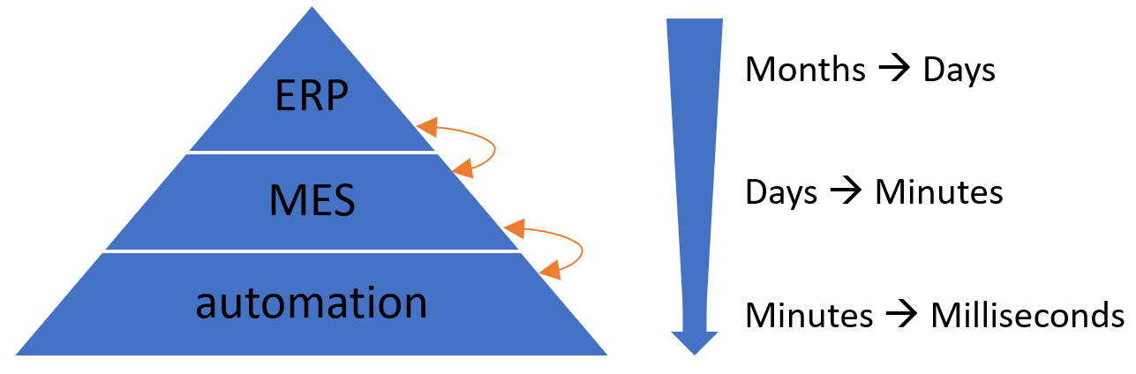

Figure 2.x: Architecture of an enterprise with MES

As shown in the figure the MES is located in between the enterprise resource planning (ERP) and the automation on shopfloor level. Furthermore, the time horizons of the different stages get significantly shorter from top to bottom. As in the ERP long- or mid-term decisions are made, the time period of interest varies from months to days, whereas for the MES single days to minutes matter. For the shopfloor level, where the actual production happens, it can even depend on milliseconds.

Since the MES has interfaces with lots of other systems, it acts like a hub for the data. The ERP provides the base-data such as orders, quality requirements and capacity planning that needs to be saved and processed in the MES. But the MES also has to receive data from the production on shopfloor level including sensor values, process data, machine status, counter ticks or measurements that get processed to business relevant units. It is also possible that the MES provides specific data for the production for instance process value specifications, target values or recipes. When it is not possible to access these data automatically, workers have to insert them manually. When the MES is seen as a hub, it is important that it is integrated horizontally as well as vertically, which means that the information is distributed on the MES level and also throughout the different levels of the pyramid.

When using a MES a database, either an external one or the MES itself, with high requirements is needed. Data has to be consistent, plausible and complete, which is also relevant for data acquisition. Furthermore, the database has to meet various security aspects so that the production is not endangered in case of power outage and other problems.

### MES in the context of Industry 4.0

The term Industry 4.0 has been circulating in the manufacturing industry for a while, but there are different approaches to revolutionizing industrial production. It is agreed that the use of information technology and increased networking can significantly improve the efficiency of industrial production, potentially increasing productivity by more than 30%. However, achieving productivity gains requires the use of applications that take advantage of these new technologies and changes in organization such as MES.

Many visionaries dream of the ultimate networking of all resources and systems in manufacturing, where each machine is aware of its capabilities and each material knows which product it will become and for which customer it is destined. While this vision has evolved, a more practical approach seeks for each resource to be able to communicate with every other resource, allowing for early error detection and an increase in the flexibility and intelligence of the machines. Decentralized decision-making will become more common, but human experience will always be needed for final decision-making. This vision is known as a Smart Factory.

The concept of a Smart Factory presents new requirements for manufacturing software such as MES. IT systems need to become more flexible in order to adapt to short-term changes in manufacturing processes easily. The increasing interconnectivity generates huge amounts of data that require semantic structuring to become valuable. This "Big Data" must be processed in real-time to derive intelligent and useful insights. Industry 4.0 has to include human involvement and concrete use cases for optimal success.

The basic principles of a MES as defined in VDI guideline 5600 provide a good starting point for the Industry 4.0 era. In particular horizontal integration and comprehensive penetration of the company are of the most important issues here. The collection of data in production, their aggregation and also the processing and displaying in real time are essential for the success of a smart factory. However, there is much more to it than the processing of data and measured values into meaningful information. In the future modern companies will depend much more on the integration of all functions and modules across all elements involved in production. In addition, the importance of cross-system data exchange will increase, which is therefore another task a MES must fulfill.

In summary, it can be stated that MES systems would be ideally suited as a central information and data hub in a smart factory. But in order to do so in perfection today's systems still need to be further developed. Still the basic approach of the MES idea is already heading in the right direction. The goal must be to synchronize all systems and functions involved in production. Transparent data exchange is the basis for a functioning future scenario. This does not just mean the pure distribution of data, but also application-related preprocessing or aggregation. For example, ERP systems only need final summary values and not the comprehensive detailed data from the individual status messages at the machine. An MES system, as the central hub, has the task to provide each user and each system with exactly the data that is expected or required.

The developments and enhancements of the MES 4.0 concept aim to satisfy market and customer demands, such as mass customization and resource efficiency, to ensure manufacturing companies remain competitive in an increasingly globalized market. MES 4.0 provides flexible software tools to support the individualization of mass-produced products and improve efficiency, which is crucial for maintaining and expanding market leadership in a high-wage, highly automated region. The concepts of Industry 4.0 and MES 4.0 will promote sustainable efficiency in manufacturing in the long term.

### Arcstone’s MES solutions

The used MES software is arc.ops from Arcstone. It features a specific tool for connecting to machines and pull the data named arc.quire, which features industries standard protocols, including OPCUA. A complete overview of Arcstones MES solutions is shown in Figure x.x.

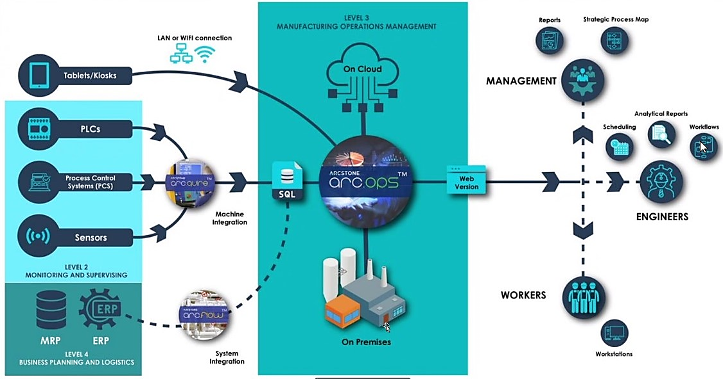Figure x.x: Arcstone’s MES solutions

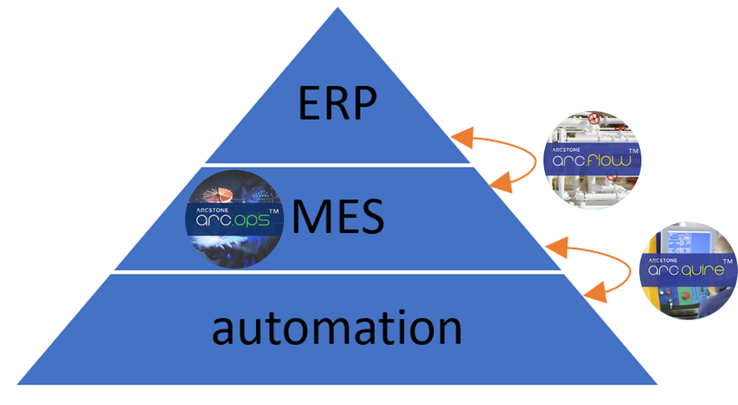When looked at Arcstones MES solutions in the context of the ISA 95 framework, arc.quire connects the automation level to the MES, arc.ops is the MES itself and arc.flow is the link between ERP and MES. This is shown in Figure x.x.

Figure x.x: Arcstone in the context of the ISA 95 framework

## Artificial Intelligence

So far, the factory is controlled by a PLC software. This software allows the developer to set clear instructions what the factory and each machine does. Instructions are worked through precisely. It furthermore needs to be controlled by workmen. The production process is started, viewed and stopped by humans. Furthermore, the quality of products needs to be screened. For a company this always means to pay wages. But how avoid these costs?

With “[the] branch of computer science that is concerned with the automation of intelligent behavior” (Luger and Stubblefield, 1993), which is called artificial intelligence (AI). This could help to take over the task of the mentioned steps of work.

The factory is supposed to be monitored and controlled by artificial intelligence. While AI comprehend many ways of implementations, this project is supposed to use neuronal networks. This chapter will review neuronal networks.

### Neuronal Network in general

When talking about neuronal network it is meant to have an artificial neuronal network. The idea is to create software that works similar like a human brain, a natural neuronal network. This network gives us our intelligence. It helps us to train our abilities, physically and more important mentally. We can adopt to situations and changes.

But how to build such a system? A computer has an architecture not matching with the brain. It is basically a calculator that can execute software which is based on mathematics. The attempt is to analyse human brain and to create models that reflect the brain. The network consists of many small entities, that are similar like the neurons. They are working like single information storages, powered by electric voltage. As messages reach a neuron, also electrical energy is sent. The voltage level is rising. At some point there is too much energy in a neuron and it will reach out and sends its information. But where to?

**“What fires together, wires together”** (Hebb, 2002) is a quote describing that neurons often reach out to each other will connect. The more often they communicate the stronger their connection will be. For an artificial neuronal network it should work similar. When raw data is put in a new system, there is no connection between the entities. The computer then need to find connections. Hebb is describing the idea of how it’s done: Data often colliding, will have some kind of link. This is how the computer can derive clusters. Once this clusters are established it can be used to solve tasks. The more tasks it solves, the more information the system can collect. This information can also lead to an evolvement of the clusters.

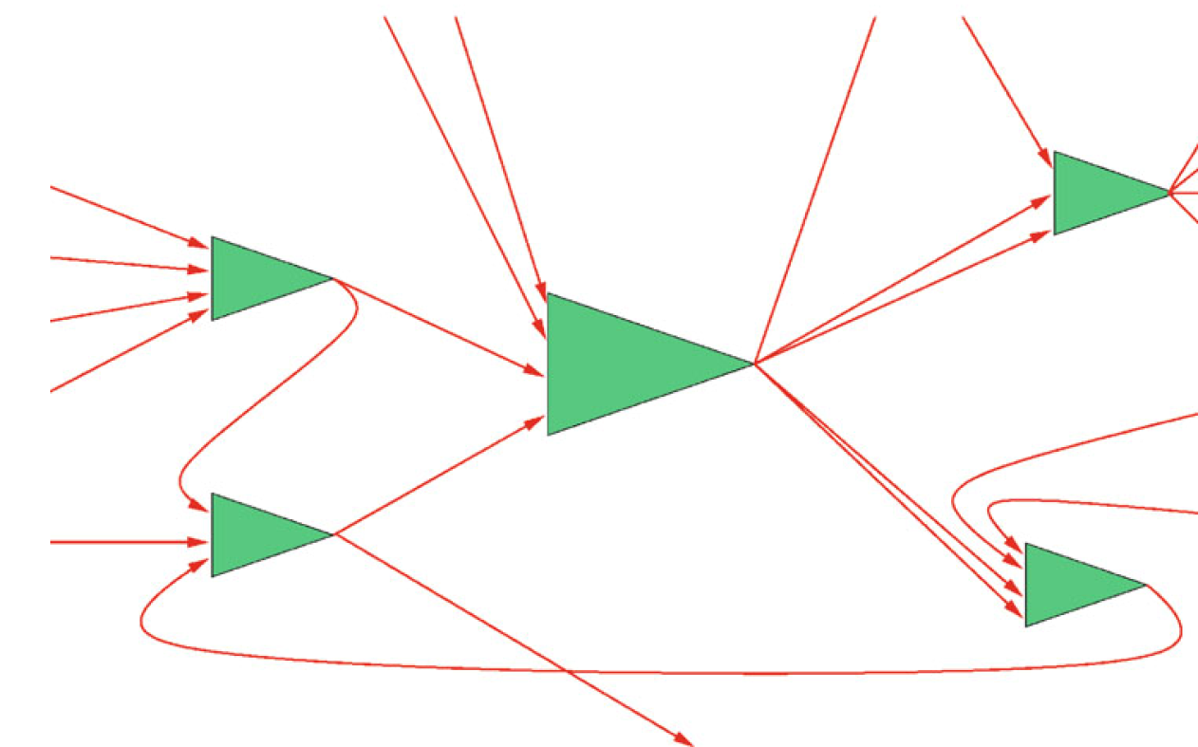

Figure 2.x: Model of network (Ertel, 2021)

The above figure above represents the network. The green triangles are the neurons connected by wires. The following picture shows how this is implemented.

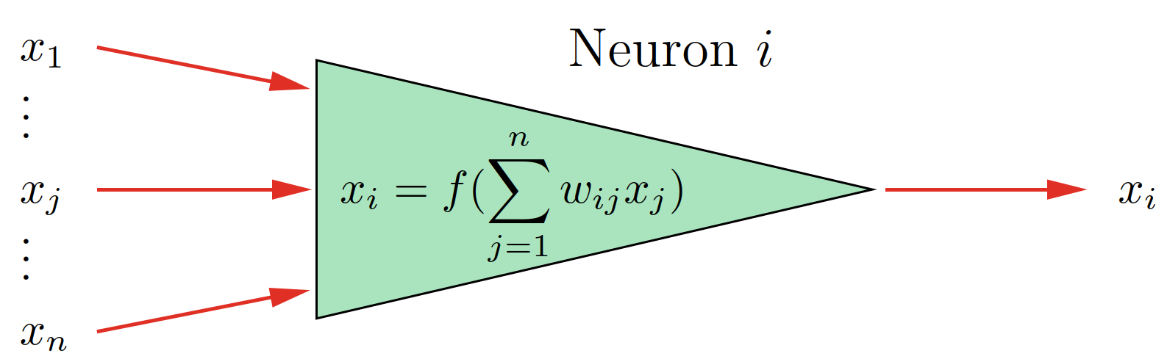

Figure 2.x: Mathematical Neuron (Ertel, 2021)

The input voltage of each wire is represented by variables named $x_{j}$ in the picture. The higher the voltage value of the human brain is, the higher the value of $x_{j}$ is in the mathematical model. The factor $ω_{ij}$ is fixed to each $x_{j}$ and represents how strong the connection to the respective previous neuron is. The better the connection, the more electrical power will go through. Despite this being a factor, its value can change, if the connection is changing as result of an adapting process. The product of each input and its factor will then be summed up. This is the output value $x_{i}$.

Despite its called learning network in most networks the input data is processed through fixed calculations. In most cases it is a kind of matrix multiplication or applying filters and mask. It is also possible to several steps of calculation. That’s why an expert is required, who knows what the network is used for. The expert can then create the processing formulas.

What is it the network is learning then? It is the adjustment of the factors $x_{j}$. When saying the network is being trained, it means that the artificial network does the calculation of the factors based on the received input data. With that the network is then able to detect patterns.

Figure 2.x: Pattern of number 2 (Ertel, 2021)

In the above picture an example of pattern image recognition is shown. The network is trained to detect numbers. It is trained as an example with the number 2 on the left side of the figure. The network should then be able to recognize the 2. What makes a neuronal network special, that it is not just able to recognize the same image of the number, but also an image with changes. That is necessary in the real world as there are for example disturbances. This is shown on the right side of the figure. Some pixels of the 2 are not in place. If there was a standard recognition, it would fail to find the 2, but we want to recognize it as a 2. That is where the neuronal network comes in to play. What the network does is applying filters and masks to the picture. This will be done until the pattern of the 2 is recognized.

Another example is face recognition. If you take a picture of a person. The next day you want to recognize the face, it will be hardly possible. Because every day a person looks a bit different. And over the years a person’s face can change immensely. The network still needs to be able to recognize the pattern of a human face. For that a series of pictures is required to enable the network to learn. It then can find similarities and use them to recognize a change face.

The examples just considered image processing. But neuronal networks can be used in different areas. In the human brain, different parts are responsible for different tasks. So every part is structured differently to match its requirements. For artificial networks it is similar. Different networks suit different tasks. That’s why there are many different models that try to attempt to rebuild a part of the brain. Each model has its benefits an application its suits. For our project it will be the convolutional neuronal network and the recurrent neuronal network.

### Convolutional Neuronal Network

The issue of most networks is that they have a vast amount of data as input. Processing all of it in just one step would take very long. This is addressed by having several steps of processing. In most networks the first step is to extract attributes. These are often referred as preprocessing layers. They often consist of filters, similar like described above capable of learning. With every layer different things can be extracted. If you take image processing as an example, there is one layer to recognize edges of the picture and a layer to extract a face. In most cases the more layers you have the more attributes you can extract. In a second step attributes will be interpreted.

In a convolutional neuronal network (CNN) most of the filters are based on the mathematical convolution. The advantage of the convolution is that it reduces the number of the factors. This helps fasten up the calculation operation.

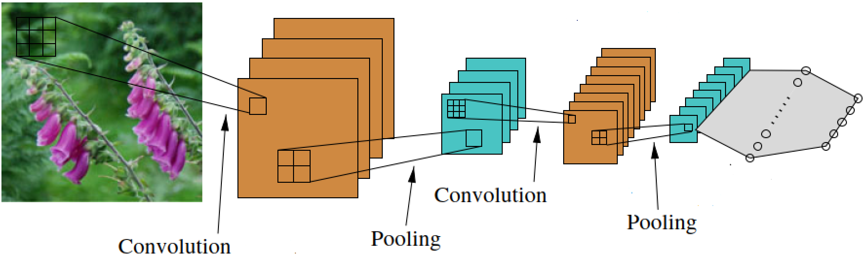

Figure 2.x: CNN working principle (Ertel, 2021)

The figure above visualizes the working principle of the filters for image processing. The input is a picture of flowers. The picture then will be filtered by using the convolution. The result is a smaller picture with highlighted attributes. The next step is pooling. Information that are similar get bundled here. This data reduction helps to safe storage space and ultimately processing time. The two steps will be repeated. The goal is to have a smaller set of extracted data. This get inserted into the neurons of the network.

The whole process is complex. Several mathematical functions need to be used the right way. Additionally, as there are less factors, they need to be more precise. This is leading to long training times. It also requires more validation, to check if the learned factors are precise enough. Otherwise, a to big error in factor value can lead to misinterpretation.

Nowadays, scientist and engineers need to have a huge knowledge about every aspect of the network to make it work correctly. It often requires a lot of experience to know which filters to use and how to order them. Also, on the mathematical side expertise is required. The filters can consist of many different mathematical operations. This can also lead to long development times.

The results of working convolutional neuronal networks are satisfactory though. For example, face recognition has not been possible with classical computation. Despite it is easier to imaging this kind of network is used for image processing it is also possible to use it in other branches. It just gets more abstract, as the constructor of the network needs to be able to create filters that work for data sets that come as example form a factory.

### Recurrent Neuronal Network

The second network that this chapter covers is a recurrent neuronal network. Compared to the human brain this is working like the short-term memory. It is capable of remembering data input for a while and even take it in consideration for new learning processes.

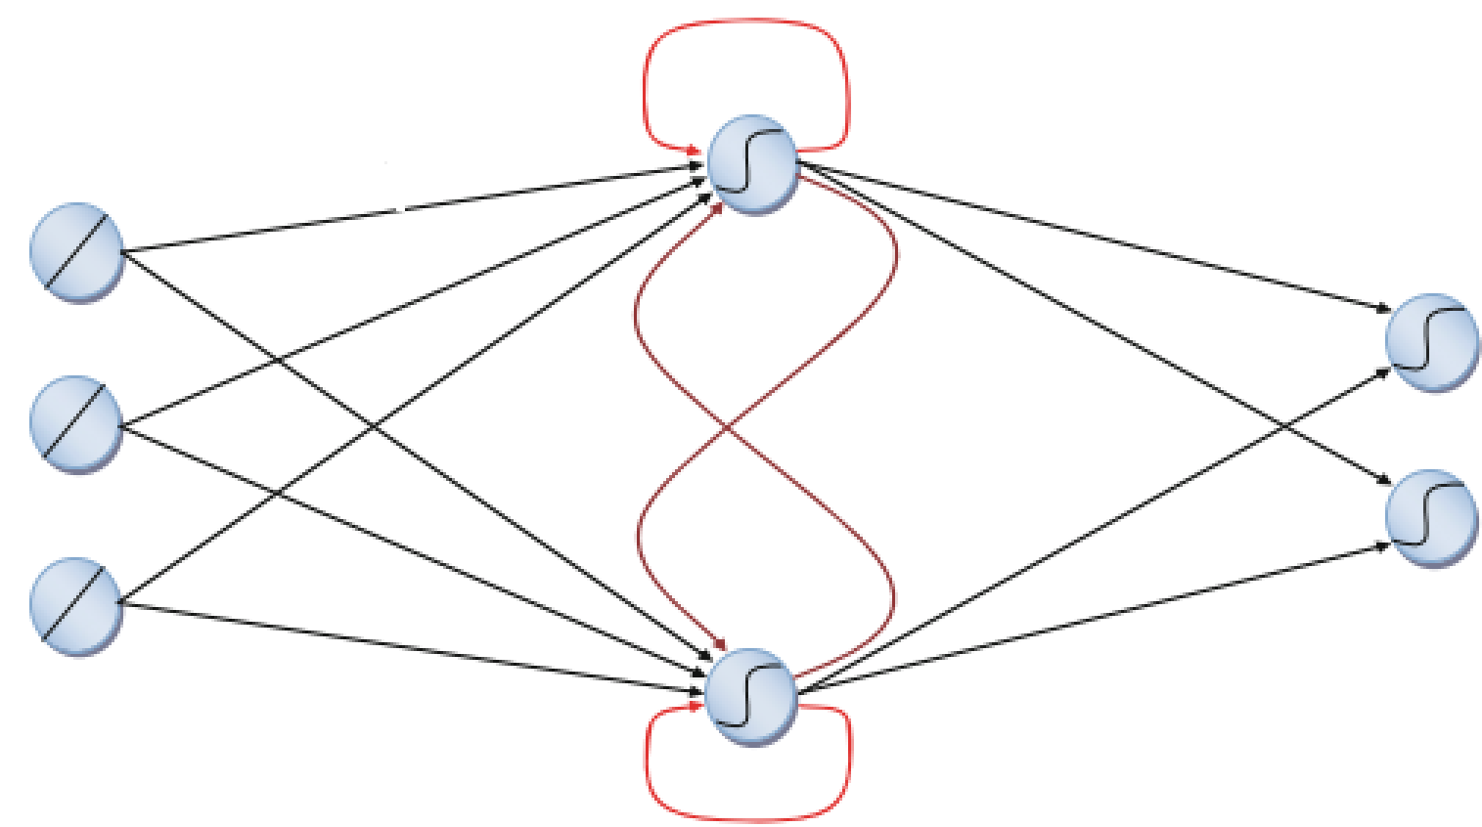

Figure 2.x: Recurrent Neuronal Network (Grum, 2022)

The figure above is a simplified visualization how the working principle. The blue points represent the neurons with connections between them. The processing order is from left to right. What makes this kind of network special are the red connections. The dark red connections are between the same layer level, the brighter red connections are to a neuron itself. This can lead to processing of a specific information for several times. It can even be transferred between different neurons a layer for several times, which makes an information available a longer time. This is what equals the network to the short-term memory.

### Summary Neuronal Networks

For Human it is often easy to acquire a series of data. The challenge of artificial neuronal networks is to provide the computer with the information. It is also required to process as much raw data as possible, without giving many rule bases. The result should be software that is capable of learning from data, extract patterns and recognize them on new data.

Neuronal networks still have a lot of potential to be unlocked in future. Scientists researching on the matter for a while and still will. The main issues are that the inspiring model, the human brain, has a huge size with approximately 1011 neurons and that its hardly possible to access the human brain. But with ongoing research artificial neuronal networks will grow in power.

# METHODOLOGY

## Flow chart

In this chapter two flow charts will explain the execution of the project, divided into the topics MES and Lernfabrik.

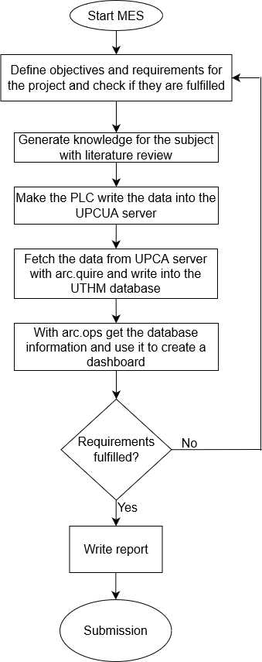

Figure 3.1: MES flow chart

Ein Bild, das Text, Diagramm, Schrift, Reihe enthält.

Figure 3.2: AI-Learning factory

## 

In this chapter the setup of the learning factory in the laboratory is described and it is shown from what basis the project has started.

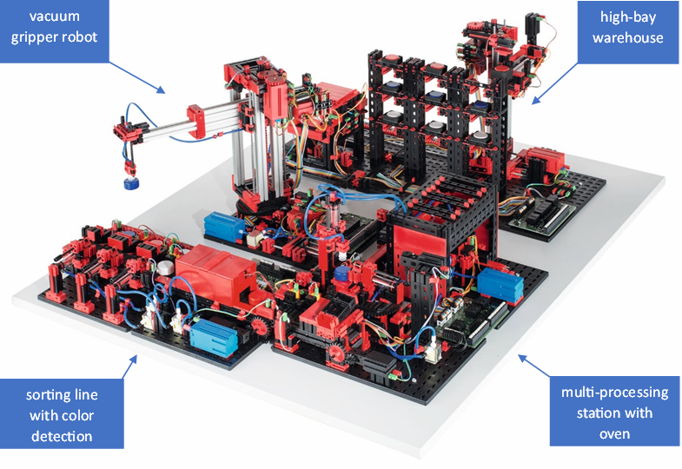Figure x.x: Fischertechnik Smart Factory

https://www.fischer.group/-/media/corporate/international/presse/images-presseinformationen/fischertechnik/2017/170926-fischertechnik-fabrik_simulation.ashx

The Fischertechnik Smart Factory is used in the project as depicted in Figure x.x. It is a learning factory that comes with many features and in the following a typical process is described.

When the process is started, the transport arm of the high-bay warehouse (HBW) moves to the storage system, picks up the wanted workpiece and places it in the output station. There it is conveyed to the pick-up position of the vacuum gripper robot.

The vacuum gripper robot (VGR) picks up the workpiece from the output station of the high-bay warehouse (HBW) and places it on the slide of the oven of the multi-processing station with oven (MPO) There the workpiece is carried in, fired and moved out again. The transport carriage with vacuum suction pad then transports the workpiece to the milling machine. There, the workpiece is placed on the rotary table and milled.

After the milling process, the workpiece is pneumatically pushed onto the conveyor belt of the sorting line with colour detection (SLD). On the conveyor belt, the workpiece passes through a colour recognition system. Depending on the colour detected, the workpiece is pneumatically pushed onto the corresponding chute.

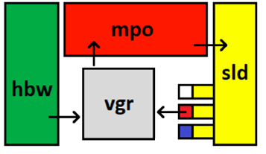Figure x.x: Schematic plan of the Smart Factory

As for the start of the project the learning factory is connected to a programmable logic controller (PLC) from Beckhoff and controlled with their software TwinCAT 3. This does not fulfil all the requirements of a factory in the context of Industry 4.0. Therefore this project deals with making the learning factory ready for the future.

# RESULTS AND DISCUSSION

## Dataflow from automation level to MES

In this chapter the data flow from the automation at shopfloor level to the MES software is described. For that all machines need to be digitized and sensorized in order for a PLC to control the production steps and read the input and output data. With this done the data can be written into a server, which is then also accessed by the MES, where it can be processed, analysed and displayed. Figure x.x illustrates the dataflow from the automation software TwinCAT to the MES arc.ops and where the data is stored during this process.



Figure x.x: Dataflow from the automation software to the MES

In the following subchapters each connection step is evaluated in more detail. First, the connection of the PLC with the server is described. Then the linking of the server data to the MES using arc.quire is discussed and lastly, the access of the data inside the MES is elaborated.

### Architecture of the connection between automation software and server

One of industries standard protocol that is widely used in automation is OPCUA, featuring flexible data transport across platforms and making machine data readable for other applications. Furthermore, it allows the user to easily write data into an OPCUA server.

When it comes to connecting the PLC to the OPCUA server there are three components that must be arranged and connected correctly. The TwinCAT environment controls the PLC and the input and output data of the PLC is written into the OPCUA server. The OPCUA expert can be utilized to test the connection and view the data. On the device that hosts the OPCUA server, TwinCAT XAR (runtime only) or TwinCAT XAE (runtime and engineering) has to be installed as well as the function TF6100 OPCUA. On each PC where a TwinCAT software product is used, the license TF6100 has to be activated. When setting up an OPCUA server authentication can be implemented by defining an username and password.

Figure x.x illustrates possible architectures of this system. Firstly, it is possible to run all components on one PC, which is obviously the easiest method. If it is wished to distribute the components on more than one PC, there are several ways to do so. For example, the TwinCAT environment with the PLC and the OPCUA server can be run on one PC, while the server data is accessed from another PC. Basically, every combination of the elements is possible, but it is notable, that a functional TwinCAT environment supporting the operation of the PLC is always on one device.

Figure x.x: Architecture examples of the connection

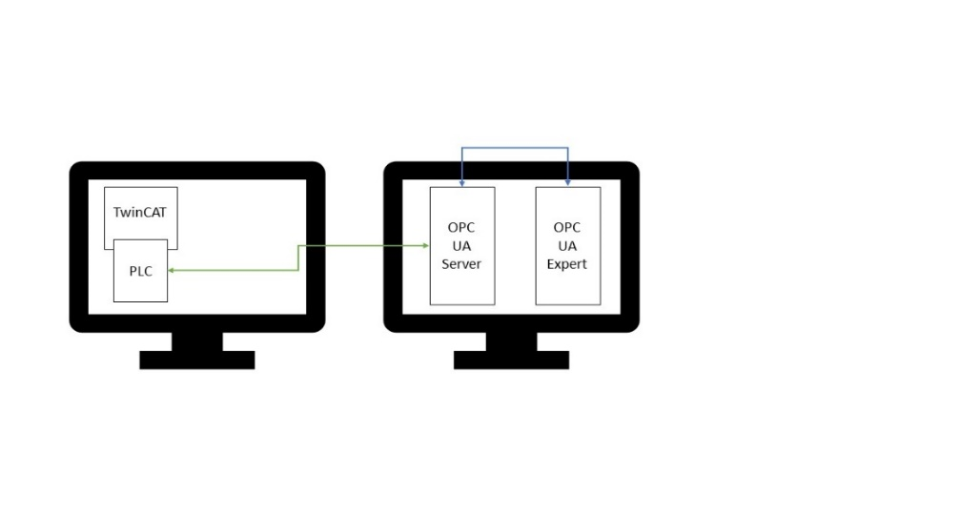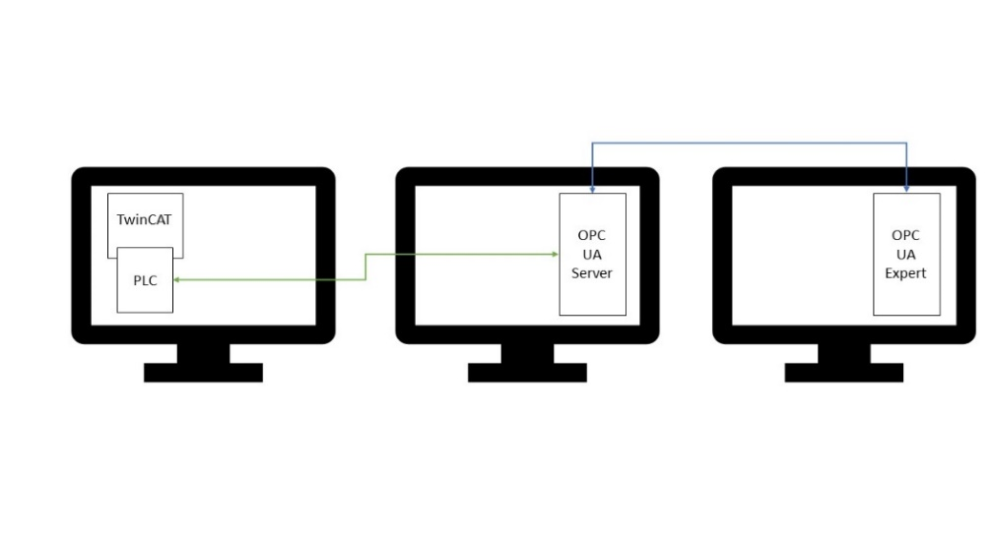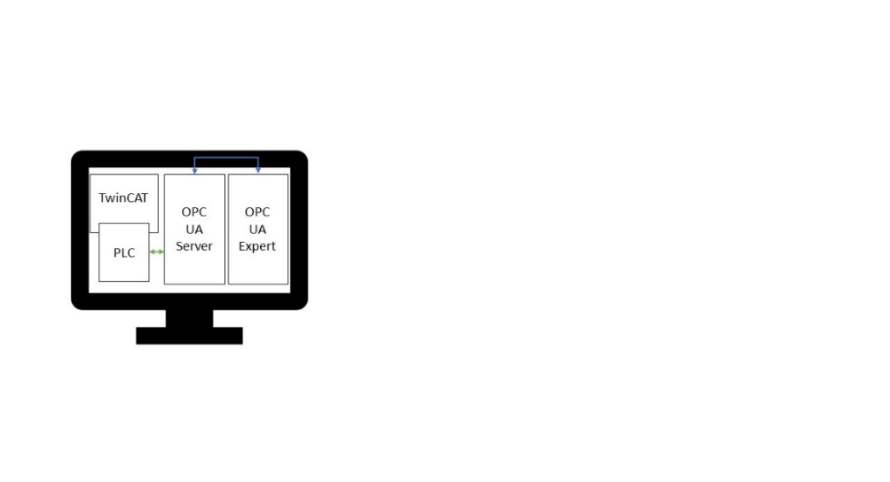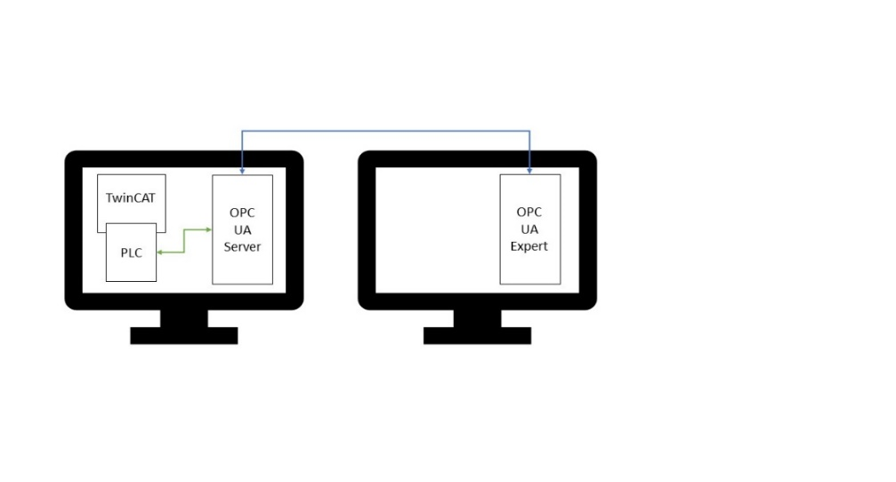

Another way of connecting the components, when they are distributed on two PCs is shown in figure x.x. The left PC is the engineering computer, where the PLC program for the server is developed and the right PC is an industrial computer from Beckhoff. Here TwinCAT also has to be installed, but functions only as a runtime for the PLC. Furthermore the OPCUA server is hosted on the industrial PC. The access to the server data happens from the engineering computer with the OPCUA expert. In this architecture it is important that a valid OPCUA license is activated in each TwinCAT software product.

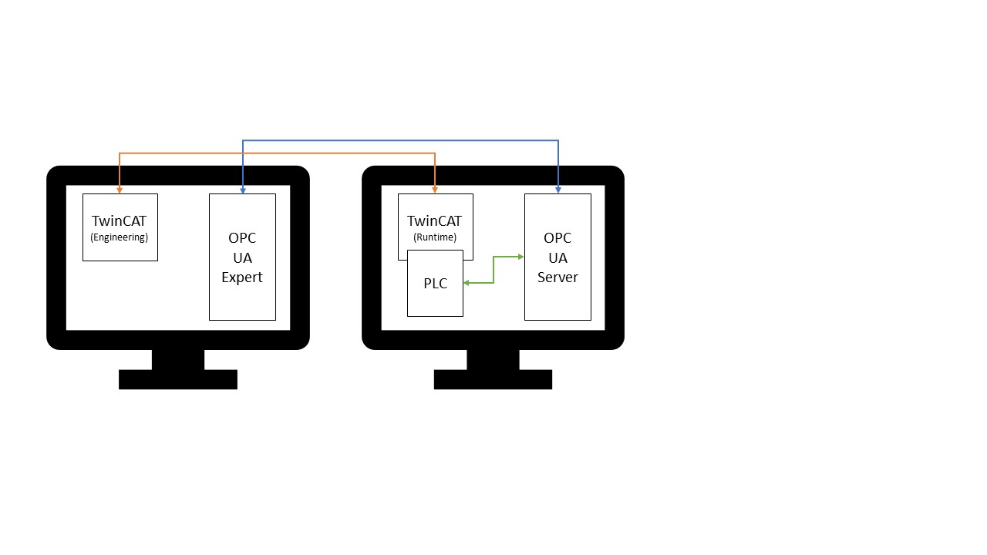Figure x.x: Used architecture for the learning factory

### Pull data from the server to the MES database

Once the OPCUA server is set up, the data can be utilized in the MES. A new arc.quire profile needs to be set up in order to pull the data to the MES. A meaningful name is chosen and a description of the profile can be added in the notes. Next, the data provider and export types have to be selected, whereby OPCUA is the provider and Database is the export for the learning factory. Refer to Figure x.x for the example settings.

In the following step the data source has to be defined as illustrated in Figure x.x. The OPCUA server URL has to be inserted as well as the publish interval and the authentication credentials if required. Afterwards, add the data that is wanted for the MES by giving each a meaningful name and inserting the corresponding node ID. If a test connection is run, the current data value is displayed in the right column.

Before the profile is ready to run, the data destination has to be specified, which is shown in Figure x.x. Most of the fields here are predefined and there is no need to change them. But the connection string has to be modified to match the username and password of the Arcstone server.

Figure x.x: General connection setup of arc.quire profile

Figure x.x: Source setup of arc.quire profile

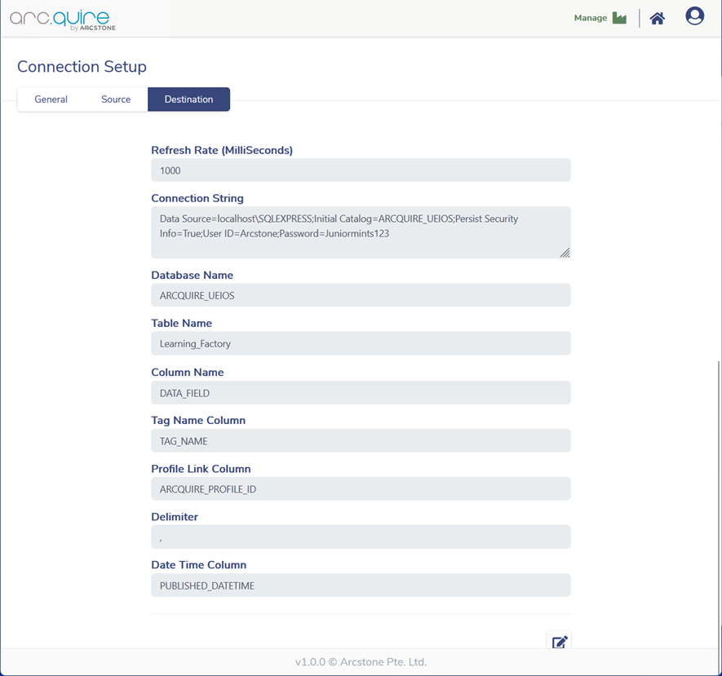Figure x.x: Destination setup of arc.quire profile

With that done, the profile is ready to be started by clicking on the play button and once it is running the selected data is automatically read from the OPCUA server and written into the SQL database. To view the database in the Arcstone server Microsoft SQL Server Management Studio can be used.

### Access data inside the MES

As the data is now available for Arcstone’s MES arc.quire a dashboard for visualization is created. When a new dashboard is made, the first thing to do is adding a data source as shown in Figure x.x. Insert a name, a short description and the connection string from the destination of the arc.quire profile that was created earlier.

Figure x.x: Add new data source to a dashboard

Navigate to data sources, which opens the dashboard data source wizard and create a new source. The data is stored in a database, so this source type is selected. Choose the previously added data source as connection. Figure x.x shows the window where a query has to be created. The query builder can be utilized to simplify the process.

Figure x.x: Dashboard data source wizard

By using drag and drop the required table can be selected as well as the columns. The SQL string can then be modified to fulfil the users demands. In the shown example only the newest value of S1_I1 is selected by filtering for the TAG_NAME and putting the ID in a descending order. Other methods of an SQL query can also be used here. Now the data is ready to be displayed on the dashboard.

For that purpose Arcstone offers a variety of options. The most common and easiest way of displaying data is the grid, which is also used for the Learning Factory, but there are also elements like the bar graph or the pie chart. The grid is basically a table, where data from the data sources can be added in the columns. Figure x.x shows the settings for a grid. The data either be directly displayed or processed further by adding a calculated field. This is useful if the output needs to be normalized.

Figure x.x: Bind data to grid

## Creating the dashboard

The dashboard should clearly visualize which station is currently running. To achieve this, appropriate sensors that indicate the status of each station have to be selected.

The first station is the high-bay warehouse. Here the end-switch S1_I1 of the transportation arm is utilized to determine whether the station is running or inactive. If the switch is pressed the sensor value equals true and the station is inactive. As soon as the transportation arm starts to move to the storage system the switch gets released and the sensor value turns to false. When a workpiece has been taken out of the storage system and is put on the output station the process is finished and the end-switch is pressed again.

The vacuum gripper robot then picks up the workpiece from the output station. To reach the pick-up position the robot needs to extent its arm and the end-switch S2_I2 is released. After putting the workpiece on the slide of the oven the arm returns to its initial position and the end-switch is triggered again. Just like for the first station a sensor value that equals false means that the robot is running.

The multi-processing station is divided in two separate stations for the visualization. Starting with the oven, which is running as long as the end-switch of the slide S3_I6 is pressed. In contrast to the previous stations the logic is inverted here. meaning that a true sensor value stands for a running oven. When the workpiece leaves the oven it is transported to the milling machine. The end-switch of the rotary table S3_I1 indicates the state of this station. If the milling process is running the switch is released and thus its sensor value is false during this time.

The state detection of the sorting line with colour detection differs from the previous stations as it is not determined if it is running or inactive. Instead, the state of each chute is derived from the sensor values and the dashboard should show if it is empty or full. The light barriers S4_I4, S4_I5 and S4_I6 return true if the chute is empty and true if the workpiece is sorted.

A summary of the sensor selection and their meaning for the states of the stations an the chutes can be found in the following Table x.x

Table x.x: State of each station and the chutes

|  |  |  |  |
| --- | --- | --- | --- |
| Station | Sensor | State | Sensor value |
| High-bay warehouse | S1_I1 | Running | false |
| Inactive | true |
| Vacuum gripper robot | S2_I2 | Running | false |
| Inactive | true |
| Oven | S3_I6 | Running | true |
| Inactive | false |
| Milling machine | S3_I1 | Running | false |
| Inactive | true |
| White chute | S4_I4 | Full | false |
| Empty | true |
| Red chute | S4_I5 | Full | false |
| Empty | true |
| Blue chute | S4_I6 | Full | false |
| Empty | true |

As not all sensors have the same meaning the sensor value needs to be modified, which is achieved by adding a calculated field with a simple if-query as shown in Figure x.x. The first input in the brackets of the if-query is the statement that is checked. If the statement is true the second input is returned and else the third input is returned. The example shows the calculation for S1_I1.

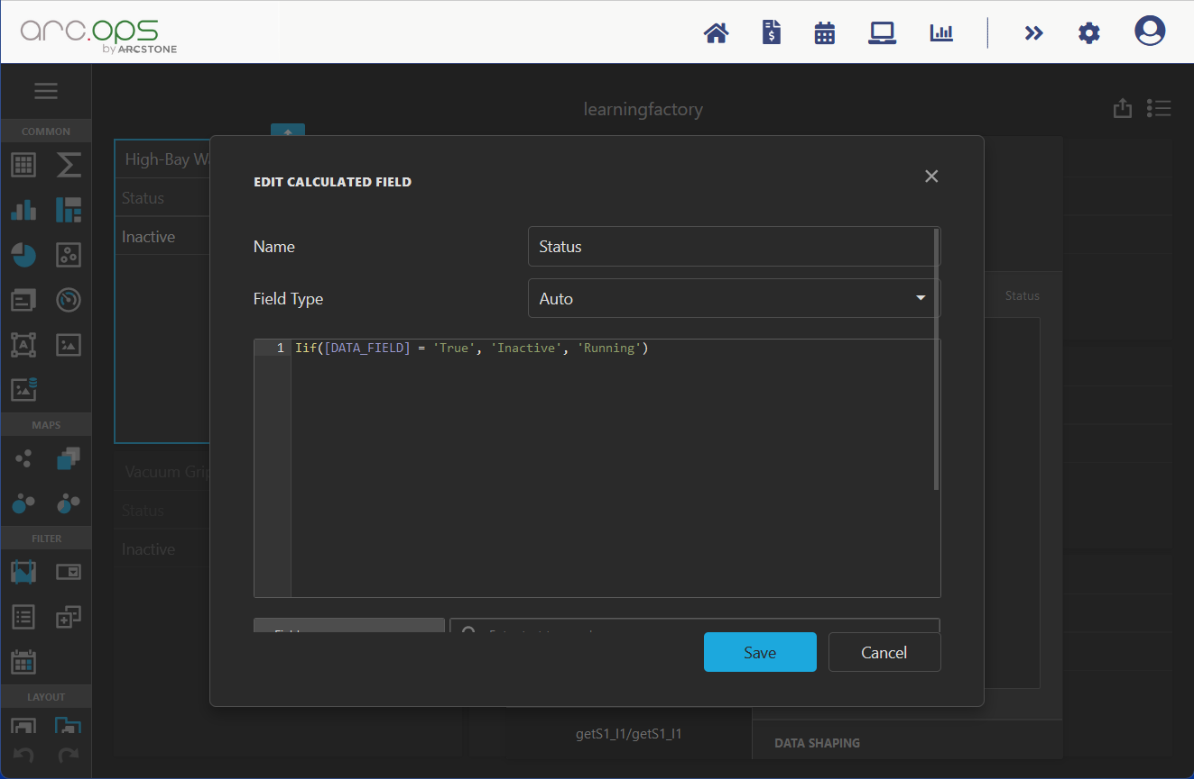Figure x.x: Calculated field

For each of the seven sensors a grid is added into the dashboard and to make the dashboard easier to understand an image of each station is added below the grid. The final dashboard is shown in Figure x.x below. In the top left corner is the high-bay warehouse, below that the vacuum gripper is shown. In the middle column the oven and milling machine are shown and on the right side are the chutes of the sorting line. In the screenshot the oven is running and only the white chute is full.

Figure x.x: Dashboard

## How the AI-Lernfabrik works

This chapter will evaluate what one can learn from university Albstadt-Sigmaringen’s AI-Campus course of the learning factory. The focus will only be on the software tools and their application. The overall goal is to set up a system that is capable of monitoring and controlling the factory. The course is showing all the steps which are necessary for implementation. In the following paragraphs each step will be analysed.

To monitor the factory, the artificial intelligence system needs to fetch the available data. Most of the available data are sensor signals. The first step is to collect all data and store them into a cloud. The data communication is done by MQTT. The first thing that is taught is a way to read the incoming data and write it into a database. For that purpose, the software tool Apache Nifi is used. The programming is done by a kind of block programming. The course is providing a sample code. As user the task is to control and change the source URI. The sample code enables the user to understand the modus operandi of the tool.

For the next step a python script is introduced. Its purpose is to request current states and to place orders, that get executed by the factory. The script will be accessed via Jupyter Hub. Basic understanding about python scripts and the python programming language are of advantage. The user should also be familiar with command language as the execution is performed via the Python Hub.

As a next step, sensor data is put into graphs. This step is not essential for the factory control, but interesting for factory analysation. Therefore, the data is put into the Amazon could. This enables the user to use the AWS Redshift tool. The course is accessing to the Redshift tool via another python script.

A second possibility of communication is introduced in the next step. The tool to establish the communication is Node-RED. The communication standard is UPCUA. Node-RED is a tool that is using block coding. The course is providing sample code. The tool is used to read form the factory, put the data into the Microsoft SQL database and control the learning factory. With that the course introduced the two most common used communication standards and useful tools to work with.

In the penultimate step the preparation for the artificial intelligence is done. Therefore, data editing is performed to have it neuronal network ready. The course is teaching how to use Node-RED and Python for that purpose. In the final step the neuronal network is fitted to the purpose of the factory. The course is also using a Python script do accomplish this. The next subchapter describes the application of the two used neuronal networks in detail.

### Applying the Neuronal Networks

The university Albstadt-Sigmaringen is using two neuronal networks to detect the current state of the Lernfabrik during a typical ordering process. To make this possible it is necessary to preprocess all data in a way that a neuronal network is applicable on it. How to preprocess the data in that manner and how to train and test the neuronal networks is described in the following.

Notice that the Lernfabrik differs from the learning factory that is used in the laboratory, which makes it hard to apply on the learning factory. Therefore, this should only provide information on what may be possible with the model in the laboratory, rather than actually make it work, More about this can be found in chapter 5.

To begin with the data preprocessing a order processed is launched in order for the Lernfabrik to provide real data for the neuronal networks. First of all, the data is acquired by receiving messages from each topic, which are the different stations of the learning factory. Each message comes with several information, such as the time stamp, the station, an acknowledge code, an active or inactive state and an optional description and target. To get a set of data to work with, the ordering process is conducted once and the raw data is written into a JSON file and saved. Therefore, this data can be used in all of the following steps and it is not necessary to repeat an ordering process more often. A sample message from the high-bay warehouse is shown in the following figure.

Figure x.x: Sample message

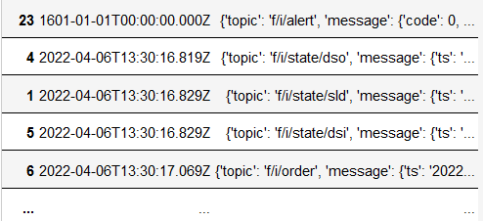The raw data is not sorted correctly corresponding to the time steps, so the first step for data preparation is to run a simple sorting algorithm. The reason for the data to be in the wrong order is that the distance between some recorded time stamps is less than a millisecond and during transmission they can get mixed up. Data is read from the JSON file and written into a list, then the time stamps is extracted from the messages and a list with two columns is created, where the time stamps are in the first column and the message in the second. Now the list is sorted alphabetically by the time stamps and the messages can be written in a new JSON file. An example is given in the figure below.

Figure x.x: Sorted messages

Now the raw data needs to be converted into a form that allows the models of the neuronal networks to work with it. The relevant data are the code, the active state and the target, which needs to be values from the same data type and range in order for the model to work efficient. Since the codes are either 0, 1 or 2 and the active state is either 0 or 1 it makes sense to also convert the target to small integer values. In this case 0 to 3 are used to represent the different targets. With that done there are only 13 input data with small integer values left. The starting values of each input is set to -1 and updated whenever a new message is received, then the integer values are written into a new file. The initial state is reached as soon as there is a message from each station.

Table x.x: Possible active state, code and target of each station

|  |  |  |  |
| --- | --- | --- | --- |
| station | active | code | target |
| vacuum gripper robot | 0, 1 | 1, 2 | 0, 1, 2, 3 |
| sorting line with color detection | 0, 1 | 1, 2 |  |
| multi-processing station with oven | 0, 1 | 1, 2 |  |
| high-bay warehouse | 0, 1 | 1, 2 |  |
| input station | 0, 1 | 0, 1 |  |
| output station | 0, 1 | 0, 1 |  |

The data is provided in the following order:

hbwstate, hbwcode, vgrstate, vgrcode, vgrtarget, mpostate, mpocode, sldstate, sldcode, dsistate, dsicode, dsistate, dsocode

Next, every state that is possible during an ordering process has to be determined. This is achieved by sorting out all identical states, but only the consecutive ones, as well as all states that have a -1 in it. Then the remaining states have to be labeled manually, because otherwise the model would not now what they mean. For example the initial state (0, 1, 0, 1, 0, 0, 1, 0, 1, 0, 1, 0, 1) is found twice in that list because it occurs at the beginning as well as at the end of a ordering process.

If two or more states are represented by the same data, they have to be summarized under one name. This happened twice in the previous labeling so it has to be changed to a meaningful common name. Now there are 9 states left, which are easy to process in the model. Lastly the states also need to be assigned to corresponding integer values.

When all the data preparation and preprocessing is done, they can finally be loaded into the model of the neuronal networks. At first the convolutional neuronal network (CNN) is used and then a recurrent neuronal network (RNN) is applied.

For the CNN the data has to be separated into input and output data. As input the 13 values of the stations are used and for output the 9 states, which are put in a 1D-array.

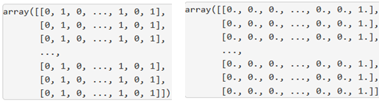Figure x.x: Input array (left) and output array (right)

The following step is to set the definitions for the sequential model of the convolutional neuronal network. The model consists of 13 input neurons and 1 dias neuron that fires random values to ensure the model will not specify too much. A hidden layer with 10 neurons is added to the model as well as the 9 output neurons and the activation functions are defined. When the model is fully defined it has to be configured using a compile function, where the standard optimizer is chosen.

When training the model with the input and output data, the results shows that it gets better and better for each epoch. After 100 epochs the accuracy is >99% and the mean absolute error is <2%. After 200 epochs the accuracy reaches 100% and the mean absolute error is near 0% and from then on, the improvements are neglectable. When the model is now tested with sample input data is it expected that it always gives the correct result.

For the RNN the previous states are also put into consideration, leading to a faster and more precise result. The output data is the same as for the CNN put the input data has to be processed further as a 1D-array is not enough for the RNN. A multidimensional array with as many the previous states as wanted is created.

Figure x.x: Multidimensional input array

For model definition a different input layer called long short-term memory is required, which contains the 13 neurons, the dias neuron plus the previous states.

The model training follows the same procedure as for the CNN, but the results are worse this time, because after 500 epochs the accuracy is about 98% and the mean absolute error 2%. It seems like the RNN does not suit the application as well as the CNN does. When tested with the same sample data the results are also correct which indicates that the RNN is still good, but there are some issues with transitions between the output states.

# CONCUSSION AND RECOMMENDATIONS

## MES

As for the end of this project the MES has been successfully connected to the learning factory and a dashboard that visualises the current state of the stations of the model has also been created. This is a significant improvement of the initial state of the learning factory, as data is now available to the MES and displayed on a dashboard, but it does not cover all the functionalities and capabilities of the MES. This chapter will discuss what can be done to enhance the usage of the MES in the future in order to get the most out of the learning factory.

When taking the guideline VDI 5600 into account, it can be seen that some of the points, like data acquisition and processing or information management are met. But still there is a lot more that a MES is capable of. At the moment only a dashboard that keeps track of the production process is used. Other features of Arcstone’s MES arc.ops are not implemented yet. For example orders can be tracked, jobs can be scheduled and viewed, workflows can be created or the personnel can be managed within the arc.ops software. As the dataflow from the automation level is established, these steps should be achievable in future projects with the learning factory.

The MES can also be seen as a data hub that connects all systems within an enterprise. By the end of this project the link to the MES is running by using ar.quire. The next step would be to connect the MES to an ERP, which can be done with arc.flow.

Moreover, there are improvements that can be done to the dashboard. Right now it is designed to be easily understandable and to fulfil the purpose of showing the current state in the most convenient way. Only the data of the sensors that are crucial to determine the state is used, but other sensor data may also be shown on a dashboard. With that it would be possible to show the production process in more detail or provide more information on the dashboard like the runtime of the stations.

The focus of this project was to show how to integrate a MES into a factory and how an enterprise can benefit from it. The dashboard is a good solution to demonstrate these points. Now it is up to others to take the usage of the MES to the next level.

## Implementation Consulting

This chapter will analyse what needs to be done in future to use the learning factory in full extent. It will be shown which hardware needs to be acquired, and what software is missing.

Siemens PLC

Figure 4.x: Controller overview (Klein, M., <https://www.hs-albsig.de/studienangebot/wissenschaftliche-weiterbildung/osteraktion/osteraktion-12-lernfabrik/?sword_list%5B0%5D=lernfabrik&no_cache=1>)

The figure above shows the prototype of the factory. All the parts not highlighted can be found in the learning factory of the Innovation-Lab. The other elements are discussed in the following.

The purple highlighted parts are a combined sensor station. It is located on top of the oven, which is already part of the laboratory’s factory. The biggest sensor of the station is a camera. It is capable of 360° filming. This is used for a web based remote control. The camera is not integrated in the software that controls the factory. It is meant for enabling persons far away from the factory to take a look. Environment sensor make up the other sensors of the station. The built in sensors are for measuring:

* Brightness
* Temperature
* Humidity
* Air quality

These values of these sensors get collected and analysed. They help to monitor the factory. With them, one can make sure that the production process is always within limits.

Highlighted by the green circle is the delivery station. The whole station is not present in the learning factory. It is used for incoming as well as outgoing goods. It consists of several elements. At the end of the production the gripper puts the workpiece into the delivery space. A light barrier is activated hereby. This information is collected by the controlling script. The information is then processed with all the other station data through the preparation steps to analyse it with the neuronal network. The missing information will be seen as an interruption to the production and a danger of a hang-up of the software.

In the following step the gripper puts the workpiece onto an colour sensor. It detect the colour of the product and this information is also stored. As soon as the workpiece is back into the storage, the software knows which colour it has. During ordering a customer can select the wished colour. The software is able to get a matching product.

In the final step of the delivery station a NFC reader and writer tags the workpiece with the production information. This is important that the workpiece “knows” what it is. Thus this step is used as a simulation to real world factories, the NFC chip of the workpiece is not read again. Meaning it is a nice to have feature for the factory simulation, but not necessary for the neuronal network.

Attached to the delivery station is the Fischertechnik txt controller. Its purpose is to collect all sensor information. After the data collection it is send to the IoT-Gateway via MQTT standard. There is no specification which chip has been used. There is also no information about the used software. This makes it hardly possible to rebuild this element.

The IoT-Gateway receives the data from the txt controller. The hardware used is a Raspberry PI, which has two purposes. The first purpose is to control the ordering process. The software used for this is the python script that was introduced in the course. The second purpose is to transmit the factory data to the cloud. This is handled with the OPCUA protocol. In the cloud the source code for the neuronal network is running. So this connection is crucial to hand the production information to the neuronal network.

REFERENCES

|  |
| --- |
| Hebb, D. O.. *The Organization of Behavior*. 1st Ed. New York. Psychology Press. 2002 |
| Picton, P.. *Introduction to Neural Networks*. 1st Ed. London. Red Globe Press London. 1994 |
| Ertel, W.. *Grundkurs Künstliche Inelligenz*. 5th Ed. Weingarten. Springer. 2021 |
| Grum, M..*Construction of a Concept of Neuronal Modeling*. Berlin. Springer. 2022 |
|  |
|  |
|  |
|  |